Gilgit:

Altit Fort

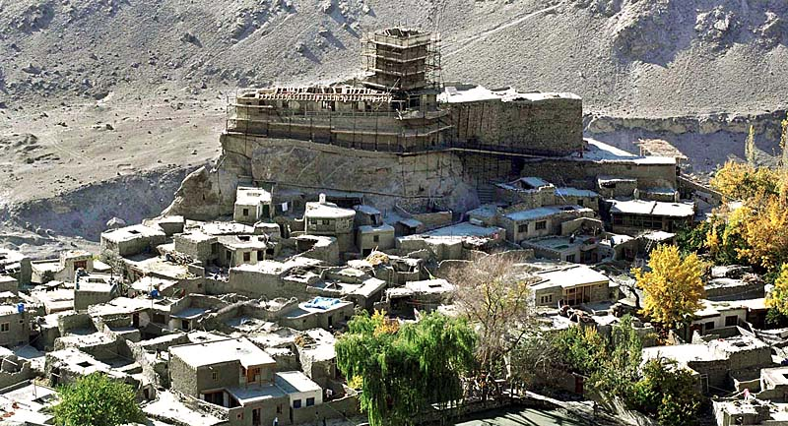

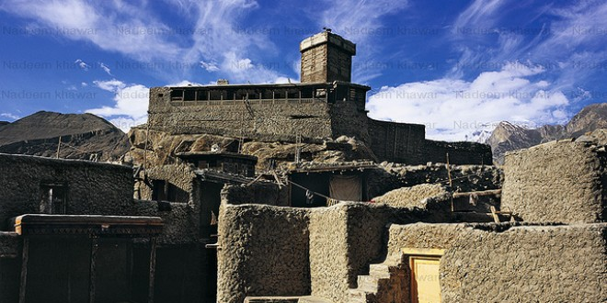

**Altit Fort** is an ancient fort at Altit town in the Hunza valley in Gilgit Baltistan, Pakistan. It was originally home to the hereditary rulers of the Hunza state who carried the title Mir, although they moved to the somewhat younger Baltit fort nearby three centuries later. Altit Fort and in particular the Shikari tower is around 1100 years old, which makes it the oldest monument in the Gilgit–Baltistan. The word Altit means *this side down* and the area around the fort is inhabited by Burusho people. The people of Altit are said to belong to the white Huns, although not much research has gone into the matter. There are several theories about their origin but local indigenous origin holds much value among the people.  It is also said that the present language Bruchiski was brought here by the white Huns in 47 A.D but there is no link between burushaski and any other language of today.